URL | backlink-guide
Title | The Complete Guide to Backlinks
Meta Description | Let’s talk about BACKLINKS. This Guide helps you set the right Backlink strategy and gives specific instructions on how to improve your Off-Page SEO!
Headline | The 2021 Backlink Guide
Reading Time | 18
Level | Intermediate
Category | SEO & SEA
Teaser | Backlinks still play a major role in your SEO-Performance. This GUIDE explains how to set the right Backlink Strategy to boost your Search Engine Rankings!

The Complete Guide to Backlinks

If you’re looking to improve your organic ranking in the search results, building high-quality backlinks should be a major part of your SEO strategy. Luckily, we created this guide to tell you all you need to know about backlinks, and how to use them to increase your rank position.

What are Backlinks
Backlinks (otherwise known as “inbound links”) are hyperlinks from other web pages to your own.

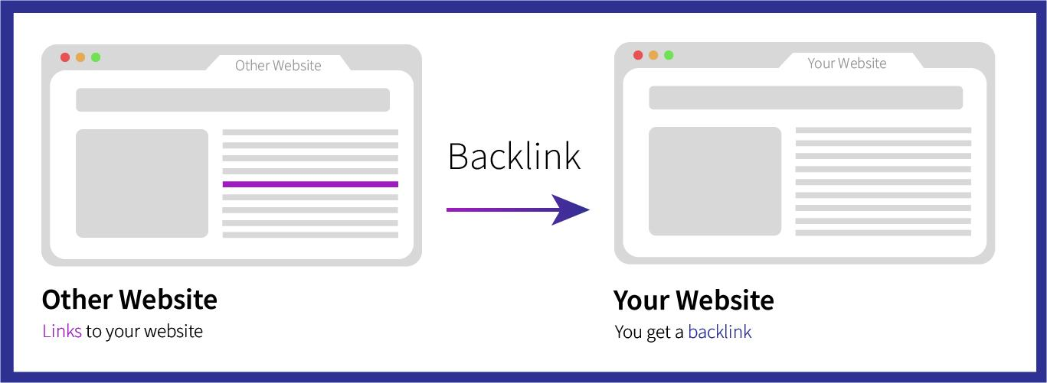
Abbildung 1 What are Backlinks

Search engines use backlinks as a “vote” of approval from other web pages, which informs them that your web page has meaningful content. Generally, the more backlinks your page has, the higher your page will rank.

However, not every backlink is treated equally. Search engines use the domain authority of the other sites to determine how valuable these backlinks are.

If high domain authority sites such as Forbes or The New York Times link to your article, this will be a much more valuable backlink than a new blog with an extremely low domain authority.

To help Google determine the value of these backlinks, they created a mathematical formula known as PageRank to measure the value of a page based on the quality of backlinks it has received.

The History of Backlinks
As stated, backlinks act as “votes” of approval for a web page that help search engines decide where to rank a web page in the SERPs. It is important to know that not all votes count as equal (as I’ll touch on later), and these votes have not always been of the same importance as they are today.

Backlinks have been a ranking factor for around 20 years now, as confirmed by a Google employee:

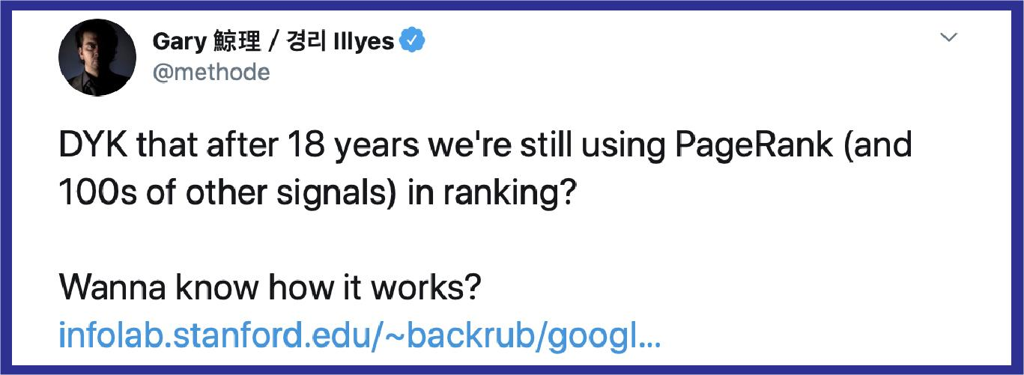
Abbildung 2 The importance of backlinks: Statement of Google employee

In fact, another Google employee (Andrey Lipattsev - Search Quality Senior Strategist) has confirmed that backlinks are in the top 2 most important SEO factors, along with page content.

PageRank has changed a lot over the years and have resulted in Google creating ‘follow links’ and ‘no-follow links’ to differentiate between spam and genuine backlinks.

Google and other search engines now use complex artificial intelligence and machine learning to define their algorithms. The main evolution of backlinks is the importance of quality of them.

Nowadays, a backlink from another blog in a relevant niche and a high domain authority is worth more than a backlink from an unrelated, low domain authority site.

The importance now lays in the quality of backlinks over the quantity. As previously mentioned, search engines are able to see the quality of backlink through follow and no-follow links.

Follow Links vs No-Follow Links
Now you know how backlinks operate, let’s look at the difference between follow links and no-follow links.

Follow links are backlinks that count as “votes” from high authority domains that help to boost your organic ranking in the SERPs.

In comparison, no-follow links are backlinks that have no impact on page rank and therefore no impact on your pages ranking position.

No-follow links can be spotted by the HTML tag:

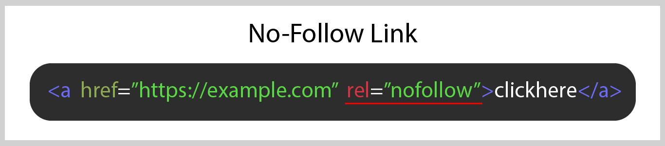
Abbildung 3 No-Follow Link

Every link tag will begin with <a and finish with a> as they are the anchor tags which let the search engines know when the link begins and finishes.

The “href” stands for “hyperlink referral”, and the URL inside the quotation marks is the web page that the hyperlink is linking to. The “clickhere” is the final piece of the link tag which relates to the text on the web page over which the hyperlink is placed.

So the Follow link of the above example would look like this.

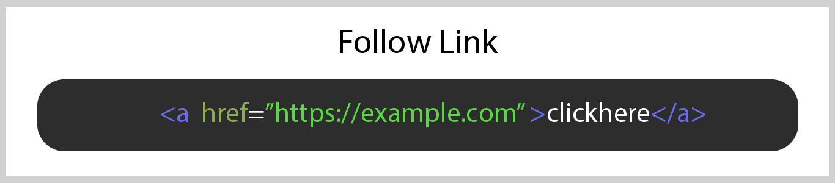
Abbildung 4 Follow Link

As you can see, the rel=”nofollow” tag is the only difference between the two links. This tag tells search engines not to count this link as a credible backlink.

If your team aren’t very tech savvy, feel free to get in touch with our web development experts who can help you with the coding behind your web pages.

Why do No-Follow Links Exist?

When backlinks and PageRank first became public knowledge, people began using black-hat techniques (practices against search engine guidelines) to get their web pages to rank higher. A major black hat technique at the time was link manipulating, including buying backlinks, using link farms, and any other strategy they could think of to get inbound links to their site all over the web.

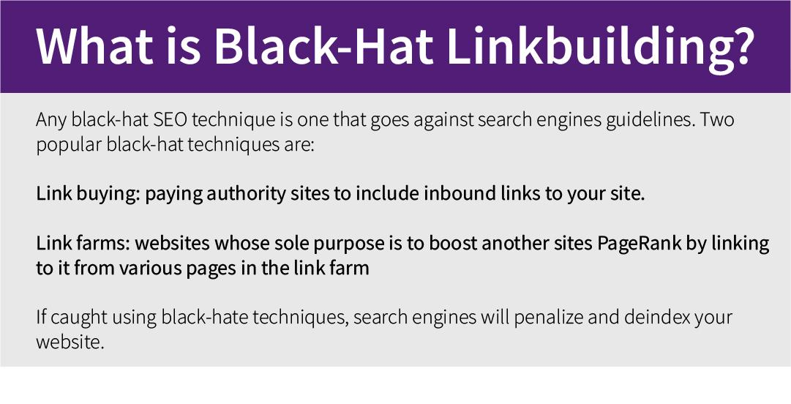
Abbildung 5 What is Black-Hat Linkbuilding

The web became a place full of spam and riddled with self-promotion and prevented people from building blogs with genuine fans and honest discussion.

Search engines became aware of this, and no-follow links were created to help them decipher between valuable and invaluable links. Wikipedia now automatically assigns the no-follow link to all of the links in its reference section, along with online comment and forum sections to help prevent spam self-promotion.

Why you Need to Avoid Black-Hat Techniques

Trying to manipulate search engines to achieve a higher PageRank is always a terrible idea. Google, Bing, Yahoo, and other search engines take this very seriously, and if they catch any website using black-hate techniques, they will usually deindex them, meaning they won’t even be visible in SERPs.

Search engines have become so good at spotting the websites using black-hat techniques that it is nearly impossible to get away with. The best way to avoid black-hat techniques is to just focus on producing great, authentic content.

How to Check if a Link is Follow or No-Follow

As mentioned, these no-follow and follow links can be seen in the HTML code of a web page.

The way to view the code behind a web page is different depending on which browser you are using. On Google Chrome, Right-Click and hit Inspect Element. If you are using Firefox, just simply Right-Click and click View Page Source.

If you are using Safari, the ability to “View Page Source” isn’t enabled by default. To enable it, open your Safari browser, click “Safari” in the navigation bar and select “preferences”. Go onto the “Advanced” tab and check the box which says, “Show develop menu in menu bar”.

Once you have done that, you can then hold down control and click anywhere on the page and select “Inspect Element”.

Now you can view the code of the page, you can hit Edit and then Find (or click the magnifying glass if you’re on Safari), to search for “nofollow” in the search box.

Any no-follow link present on the site will be highlighted for you.

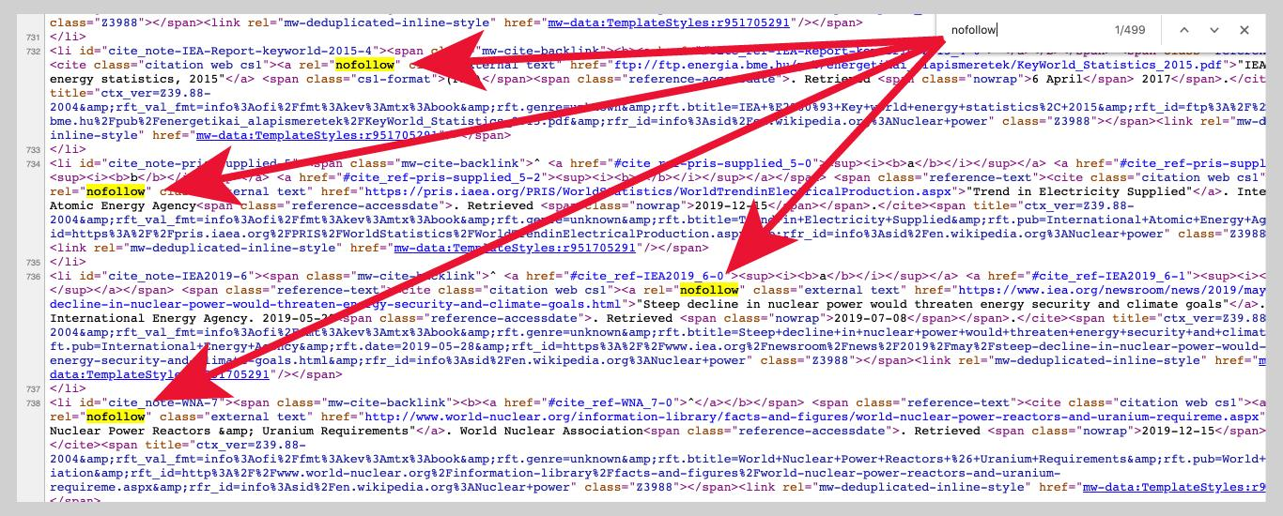
Abbildung 6 No Follow Link Overview

The Best Backlink Building Strategies

When it comes to building genuine backlinks that will affect PageRank, there are several strategies you can use to help. Getting authority websites to link to your content can be challenging, especially for newer websites, however following these steps can help you build backlinks, and subsequently rank higher in the SERPs.

1. Create Amazing Content
The most important thing you need to do if you want to gain organic backlinks is to create content that other websites will want to link to. This content could be a blog post, a video, software, or anything that people would be interested in and valuable enough to want to share with their following.

Make sure to make your content engaging, using real life examples, etc. Read our GUIDE on how to use content marketing to improve your SEO.

2. Guest Blogging
When the importance of inbound links became public knowledge, guest blogging became an over-used tactic of many bloggers in a bid to improve their SEO ranking.

Guest blogging is simply the process of writing an article for another website, in which you can usually include a link back to your own blog. Whilst it takes work to write a blog post for someone else's platform, it can help you gain a valuable backlink.

As this became more popular, Google realized people were writing low-quality blog posts in exchange for links, and so set out to crack down on marketers that abused guest blogging. Matt Cutts, the head of Google's webspam team, declared that we could "Stick a fork in it: Guest blogging is done."

The key with guest blogging is to write content of an extremely high quality that is worthy of being shared with the followers of reputable websites in your industry. Just don’t rely on guest blogging alone for your backlink strategy as search engines have been able to become very clever at figuring out which guest posts are used purely to build inbound links.

3. Reach out to Authority Sites
You could write the most amazing piece of content, but how can you get people to link to it, especially if you are a new blogger with a small following?

You need to reach out to the owners of these websites, but you need to give them a reason to link to you. Just begging for a link won’t make anyone want to link to you but using this method can give blog owners a completely valid reason to link to your content.

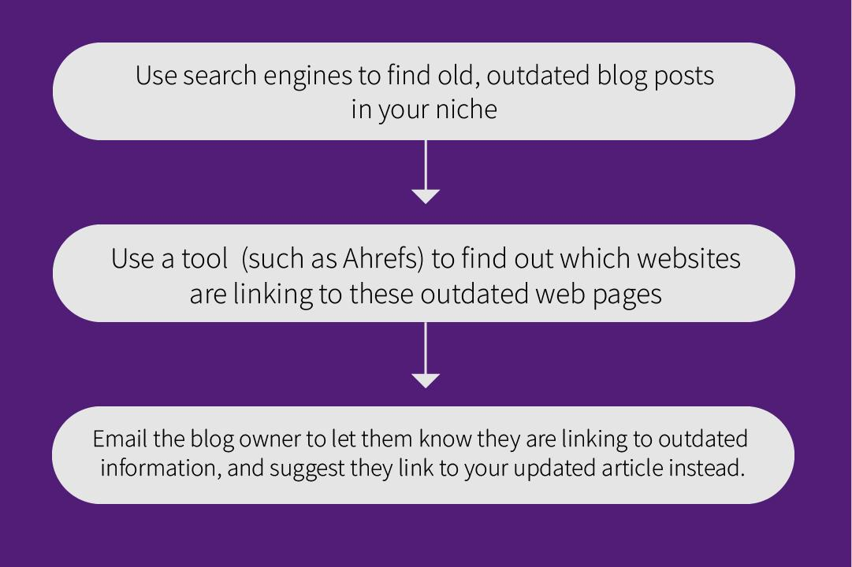
Abbildung 7 How to approach Authority Sites for new Backlinks

You can also use the ‘Check My Links’ Google Chrome extension to find which broken links (404 error pages) authority sites in your niche are linking too. Send an e-mail over to the blog owner, letting them know which of their outbound links are broken, and suggest some of your content that they could link to instead.

Take a note that with all of these, if you don’t have amazing content, no one is going to want to link to it, even if the current content they link to is outdated. Therefore, creating shareable, high-quality content is the most important step of your link building strategy.

4. Link Roundups
Have you ever seen a blog post titled something like this?

Abbildung 8 Blog Title with CTA to Content-Sharing

Some bloggers create blog posts to share other people's content with their own followers, otherwise known as a link roundup. These are not the same as link farms, as this is just one individual post designed to give their audience more value by sharing other pieces of content they will enjoy.

If you manage to get your website included in a few link roundups, these can provide you with valuable inbound links to help boost your PageRank.

Search in Google for “(Your niche) link roundup”, and politely email the creators of the roundups you find a piece of content which you think would be a perfect fit for their roundup. Remember, just because you ask doesn’t mean they will include your website. Your content needs to provide their followers with some sort of value for them to be willing to link to it.

5. Post Content to Social Media
Before I tell you how posting your content to social media can help you search ranking, let it make it clear that links from social media sites do not count as your traditional backlinks. Most links from social media count as “nofollow” links, and therefore do not impact PageRank.

Even Matt Cutts, who we spoke about earlier, said: “Facebook (and) Twitter social signals (are) not part of Google search ranking algorithms.”

Despite this, posting your content to social media can help get more eyeballs on your website. This can increase other SEO factors such as time on site. Increasing the views on your website is never a bad thing to do, even if it doesn’t directly impact your rankings.

A blog owner could see your post on Facebook, click on the link, enjoy reading your article and then link to it in their next article. All of a sudden, you’ve gained a backlink just from posting your content onto social media.

6. Backlink Analysis
It’s all good putting in these strategies to help increase backlinks, but how can you measure if they’re actually working?

Backlink analysis can help you see all the backlinks your website currently has, as well as the number of “nofollow” links. Using this analysis regularly can help you see the increase in backlinks, as well as how these increased backlinks are affecting your overall SEO by checking stats such as your domain authority and page rank for different keywords.

However, it isn’t only your own website that you should be conducting analysis on. You should also conduct backlink analysis on your competitors, to see how easy or difficult it will be to outrank them and give you inspiration for your own link building techniques.

To complete backlink analysis, simply choose the websites you want to analyse, and use software such as Ahrefs, Moz, or SEMRush to get a full overview of the domain's backlink performance.

Should you put Your Blog Under a Different URL?

When it comes to choosing your blogs URL, you have two different options, keep it on your webpage, or put it on a separate URL.

Let’s say your website is www.example.com

If you keep it on site, you can either have it as a subdomain or a subdirectory (otherwise known as a subfolder). A subdomain would look like ‘blog.example.com’, whereas a subdirectory would look like ‘example.com/blog’.

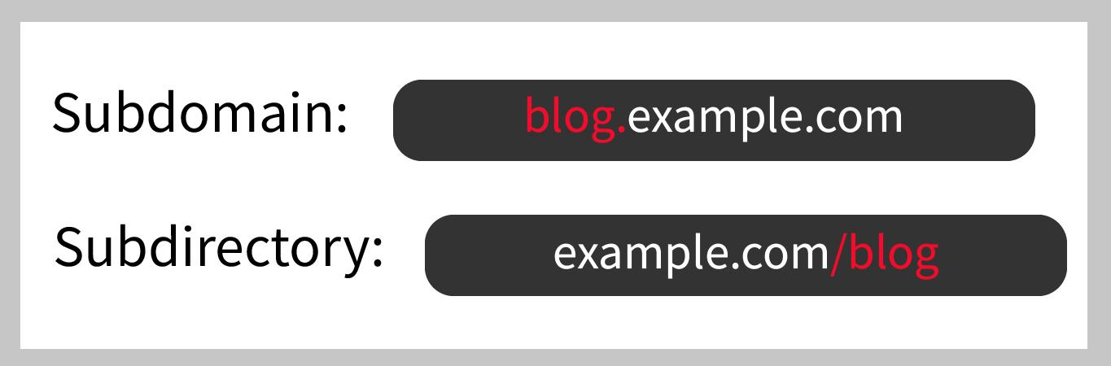
Abbildung 9 The right Blog Domain: Subdomain vs. Subdirectory

If you were to create a blog with a separate URL, it may look something like www.exampleblog.com. It has a totally different URL, meaning it is a totally different website.

So, what should you do when it comes to your blog? The short answer is to keep it as part of your main URL, preferably as a subdomain.

There are three main reasons why integrating a blog to your websites URL is preferable:

Firstly, it allows visitors to your blog to easily visit the other pages on your website that result in conversion such as ‘Contact Us’ or ‘Work with Us’. This creates a much better user experience as they won’t have to come off the blog site to visit your company's site. Why give a potential customer a reason to leave your site?

Secondly, an integrated blog has its SEO benefits, in particular regarding backlinks. This is because every backlink your blog posts receive, your whole site's SEO strength will improve, meaning all of your pages will rank higher in the SERPs. Also, Google and other search engines love content-rich authority sites, so having all your content in one place will further improve your SEO efforts.

Simply put, if you care about SEO, make sure your blog is integrated with your company's website.

The reason a subdirectory would be a better choice than a subdomain is because it helps Google crawl new blog posts faster, and also backlinks gained on one piece of content can help other pieces of content and web pages under the domain to rank higher.

In comparison, a subdomain would take a lot longer for Google to crawl and therefore a lot longer for it to rank highly in the search rankings.

Our web development experts can help you make sure your blog is correctly set up as a subdirectory, as well as optimizing your website for perfect user experience and SEO by focusing on a functional back-end development and a modern, fancy front end.

If you want an audit of your current website, get in touch with one of our experts now.

The Key Takeaways
As they are one of the two most important factors affecting SEO, backlinks are something to pay attention to.

A study by Backlinko actually found that more backlinks equal a higher page rank. In fact, the average number 1 result had an average of 3.8x more backlinks than positions 2-10.

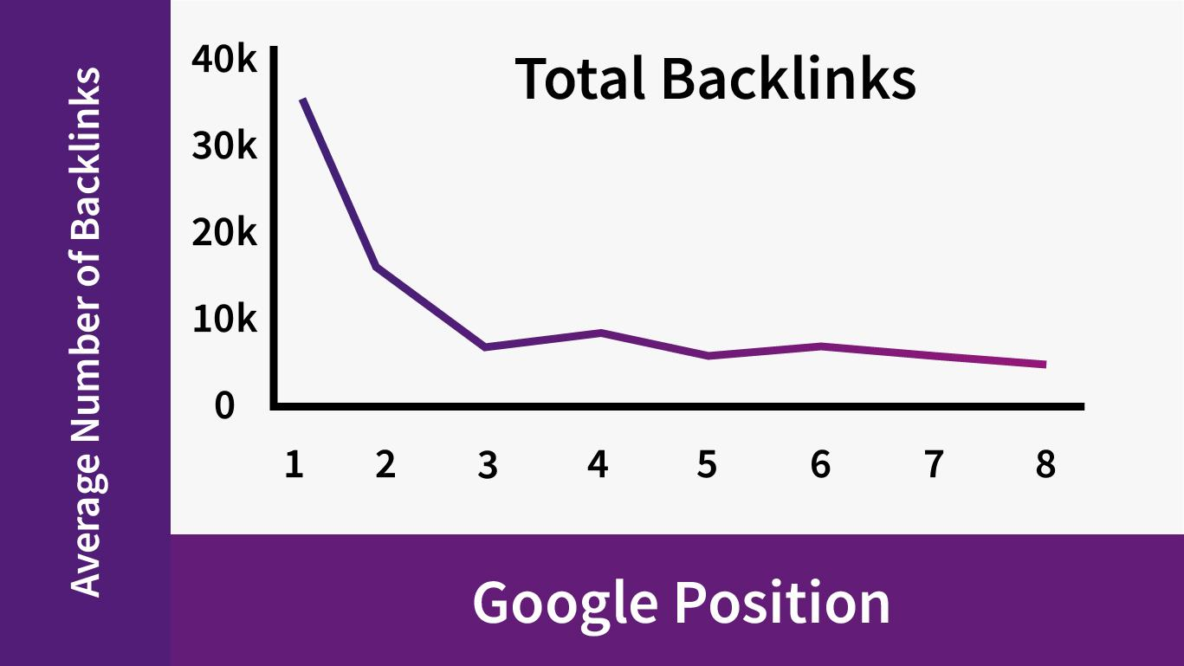
Abbildung 10 Statistic on Number of Backlinks and Google Ranking

The same study found that over 95% of web pages on the internet have 0 backlinks, meaning just 5% have an immediate advantage.

We have SEO and Web Development experts who know everything about websites and search engines. If you want any help with setting up your blog or website with a fancy front end design to make your web pages more attractive, or you want help with setting up a backlink strategy to help your web pages climb the search rankings, contact us today for a free audit of your current online presence.

